CSA05-DATABASE MANAGEMENT SYSTEMS
LAB OBSERVATION
EXPERIMENT:18
AIM:
To implement Cursors using program in MySQL.
Problem:
Problem- 1
Write a Cursor program using MySQL to retrieve the email-ids(build an email list) of employees from employees table.
SQL QUERIES:
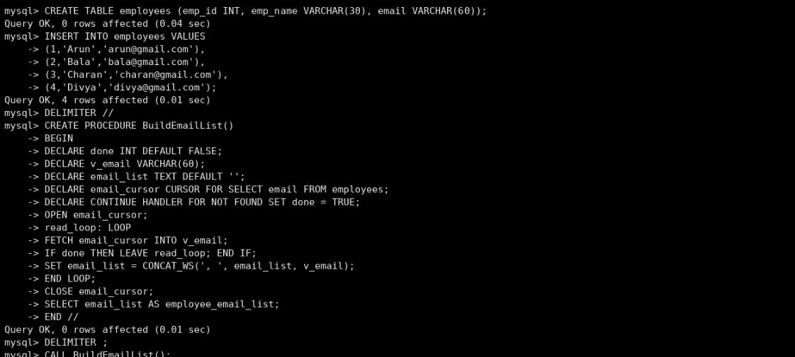
RESULT:
Thus the Functions using program in MySQL executed successfully .

